The Project Lifecycle

Date: xx January 2018 Time: xxxxxxxx

Answer THREE of the FOUR questions.
If more than three questions are answered, the best three marks will be counted.
Division of marks: All questions carry equal marks.

BEGIN EACH QUESTION ON A FRESH PAGE

Number of answer books to be provided: ONE
Calculators permitted: Casio FX-83/85 MS/ES/GT+ ONLY
Dictionaries permitted: None
Additional materials: None
Can question paper be removed from the examination room: No

Question 1

This question relates to the project lifecycle.
- The figure shown below (F1) represents the processes required to deliver a project into operation. Provide answers to the following questions:
- Give a brief description (50 words) of each of the processes in the ‘product development’ stream. [3 marks]
- What is the relationship between the processes in the ‘product development’ stream and the processes in the ‘project delivery’ stream? [2 marks]
- Which processes relate to risk management? [2 marks]
- Describe a planning process which integrates both process streams. [5 marks]

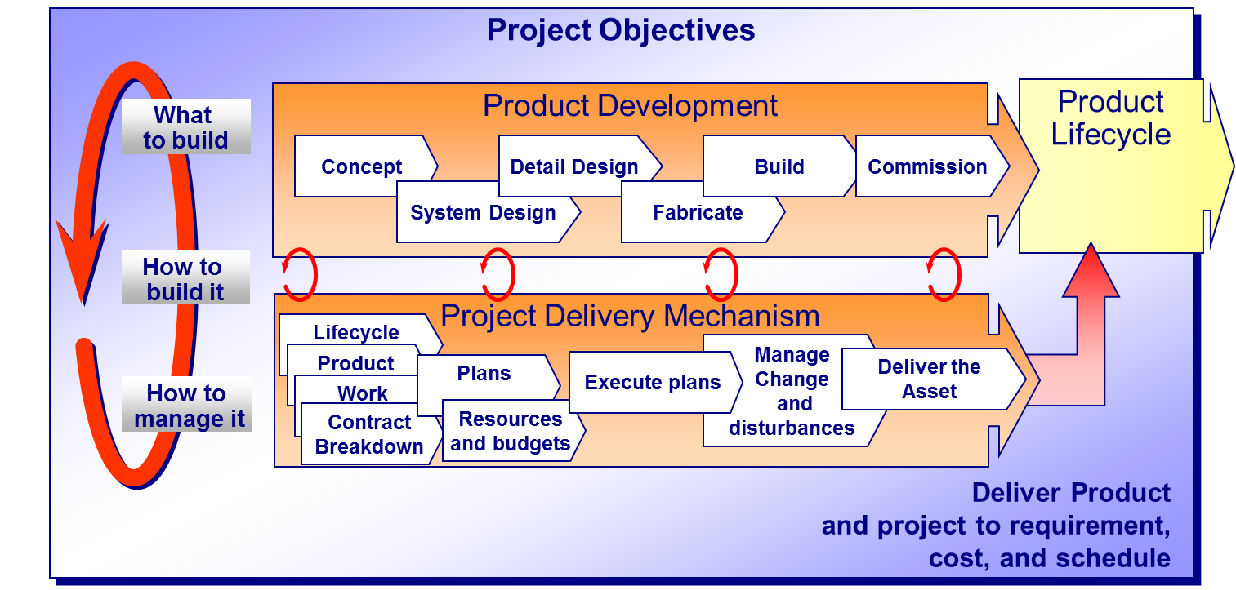
F1 – Project Lifecycle processes
- Describe the rework cycle together with its impact on project progress. [3 marks]
- What is meant by the ‘right hand’ and ‘left hand’ planning rule, and give an example to illustrate your answer? [3 marks]
- Provide a definition of an integrated project team. [2 marks]

Question 2

This question relates to High Reliability Organisation (HROs)

- Define an HRO and provide an example of an HRO? [5 marks]
- Provide a brief description of the following parameters for an organisation to become an HRO, you may wish to use business or operational examples to provide amplification or emphasis:
- Preoccupation with Failure.
- Reluctance to Simplify Interpretations.
- Sensitivity to Operations.
- Commitment to Resilience.
- Deference to Expertise. [10 marks]

- Briefly discuss the conflict between shareholder value and establishing/maintaining an HRO. [5 marks]

Question 3

Senior management intend to shorten an important business project by 4 weeks and have asked you to advise the cost of the reduction. The following network (N3) provides details of a project, and the associated cost trade off data for each activity is provided in table (T3).

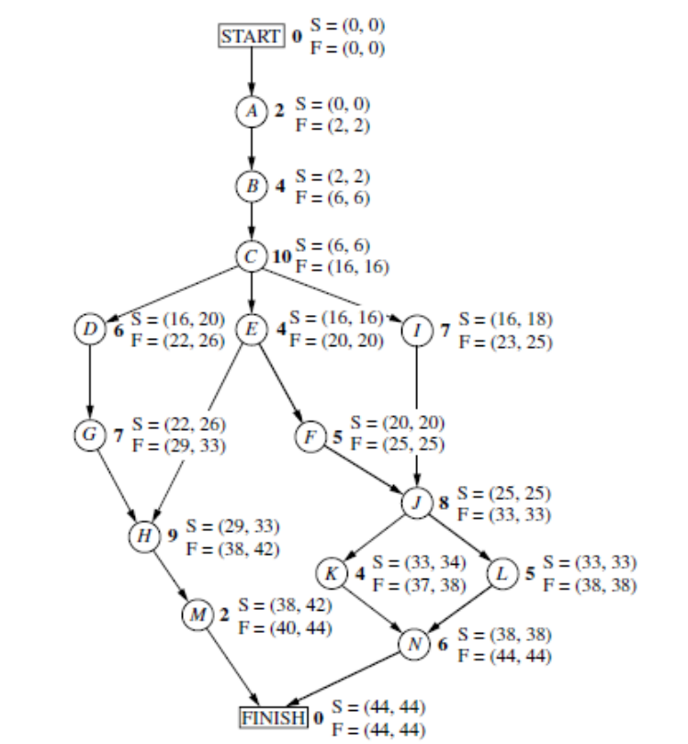
Project Network N3

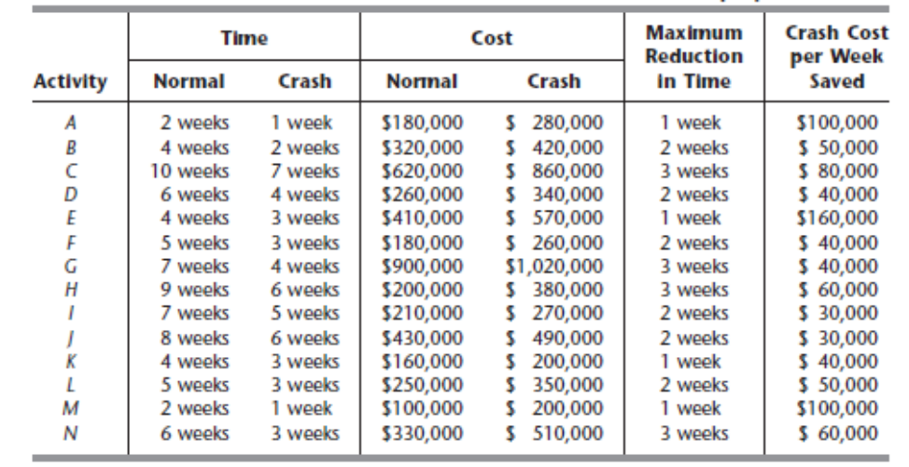
Cost Trade-off Data T3

- Study the project network N3 and identify the paths through the network together with the length of each path in weeks. [5 marks]
- Using this data identify the least cost strategy for reducing the project by 4 weeks. [15 marks]

Question 4

This question concerns CPM/PERT analysis for a ‘normalised’ project. The activities (in weeks) are detailed in Table T4.

Activity | Build logic | Pessimistic Time (weeks) | Medium Time (weeks) | Optimistic Time (weeks)
A | -- | 5 | 6 | 7
B | - | 1 | 3 | 5
C | - | 1 | 4 | 7
D | A | 1 | 2 | 3
E | B | 1 | 2 | 9
F | C | 1 | 5 | 9
G | C | 2 | 2 | 8
H | E, F | 4 | 4 | 10
I | D | 2 | 5 | 8
J | H,G | 2 | 2 | 8

Table T4
- Draw a CP Network in ‘activity on line’ format [2 marks]
- Calculate ‘Mean Time’ and ‘Variance’ for each activity [3 marks]
- Using ‘mean’ durations to calculate ‘earliest start’, ‘earliest finish’, and slack for each activity (show on your network). [3 marks]
- Identify the ‘critical path’ on your network and calculate the expected completion time. [2 marks]
- What is the probability that this project will be completed on or before 22 weeks (the required tables are attached? [4 marks]
- What is the probability of completing the project in 20 weeks? [4 marks]
- Why is Monte Carlo simulation better for calculating the probability of completion within a specified period? [2 marks]

